10/8/2023

Viet My Tran Le s5235877 – William Luvant s5287580 – Liangxian Zhao s2869753

Sydney Airbnb Application

2810ICT 7810ICT User Manual

Table of Contents

Development Virtual Environment 2

Video Demonstration 2

Main Window 2

Retrieve the information of all listings by selected time 3

Distribution of price of all listing properties 4

Retrieve all records that search by keywords 5

Analyse cleanliness based on the number of reviewers 6

Display rating of properties 8

# **Development Virtual Environment**

* Anaconda 3
* Python 3.9 (sqlite3, panda, wxPython, Matplotlib, numpy, pytest, coverage, unittest)

# **Video Demonstration**

Video demonstration of this Sydney Airbnb Application will be uploaded separately on Canvas submission page.

# **Main Window**

User access the main window of Sydney Airbnb Analysis Application. There are five function buttons that are specifically designed, namely: Retrieve By Time, Housing Price Trend, Keyword Search, Analyse Cleanliness, and Properties Rating.

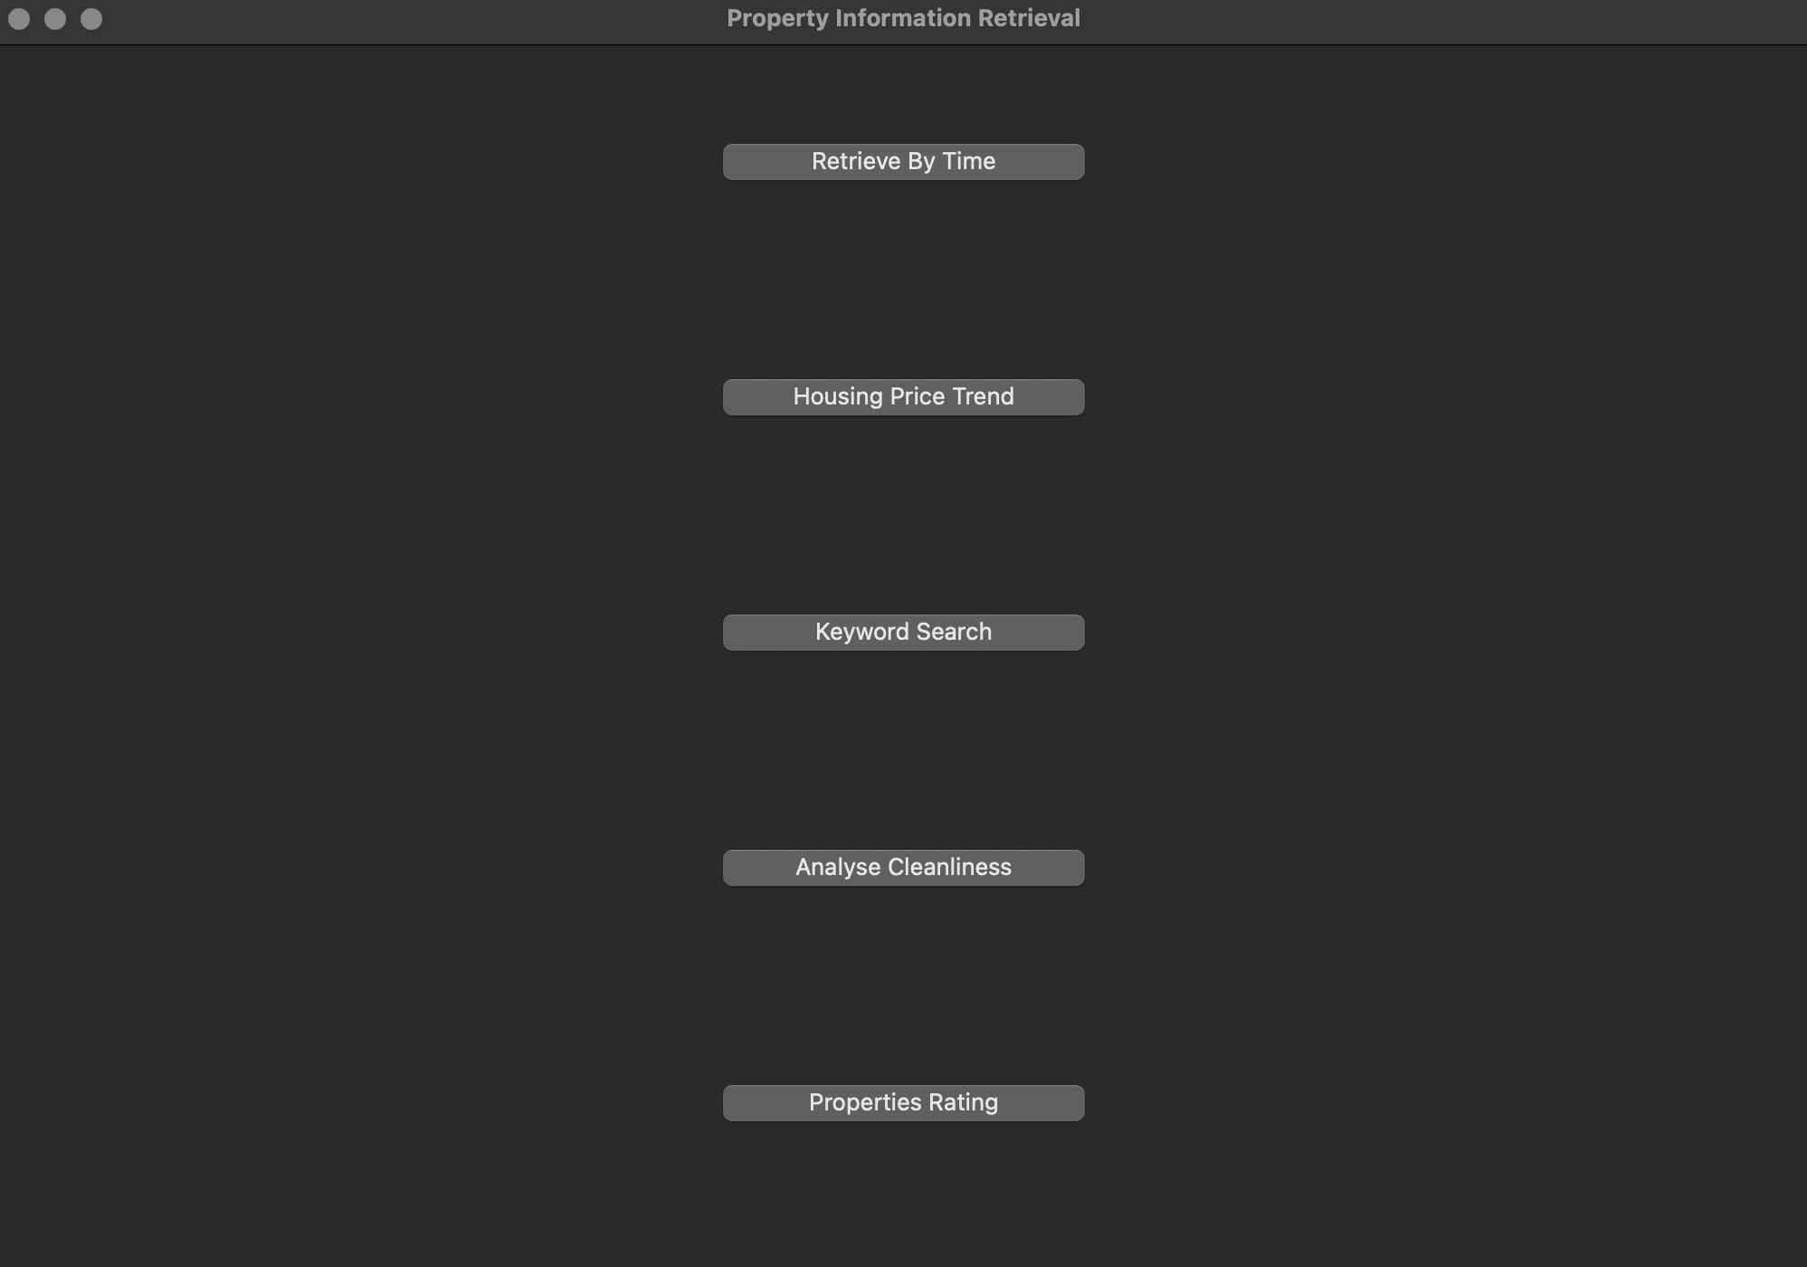

# **Retrieve the information of all listings by selected time**

* Users enter the StartDate and EndDate, and click “Find” button
* Datetime must be year/mm/dd, otherwise error message will be shown
* Not Found result only exists when users enter invalid date as well as not fill up blank
* User can click “Back” button return to main window

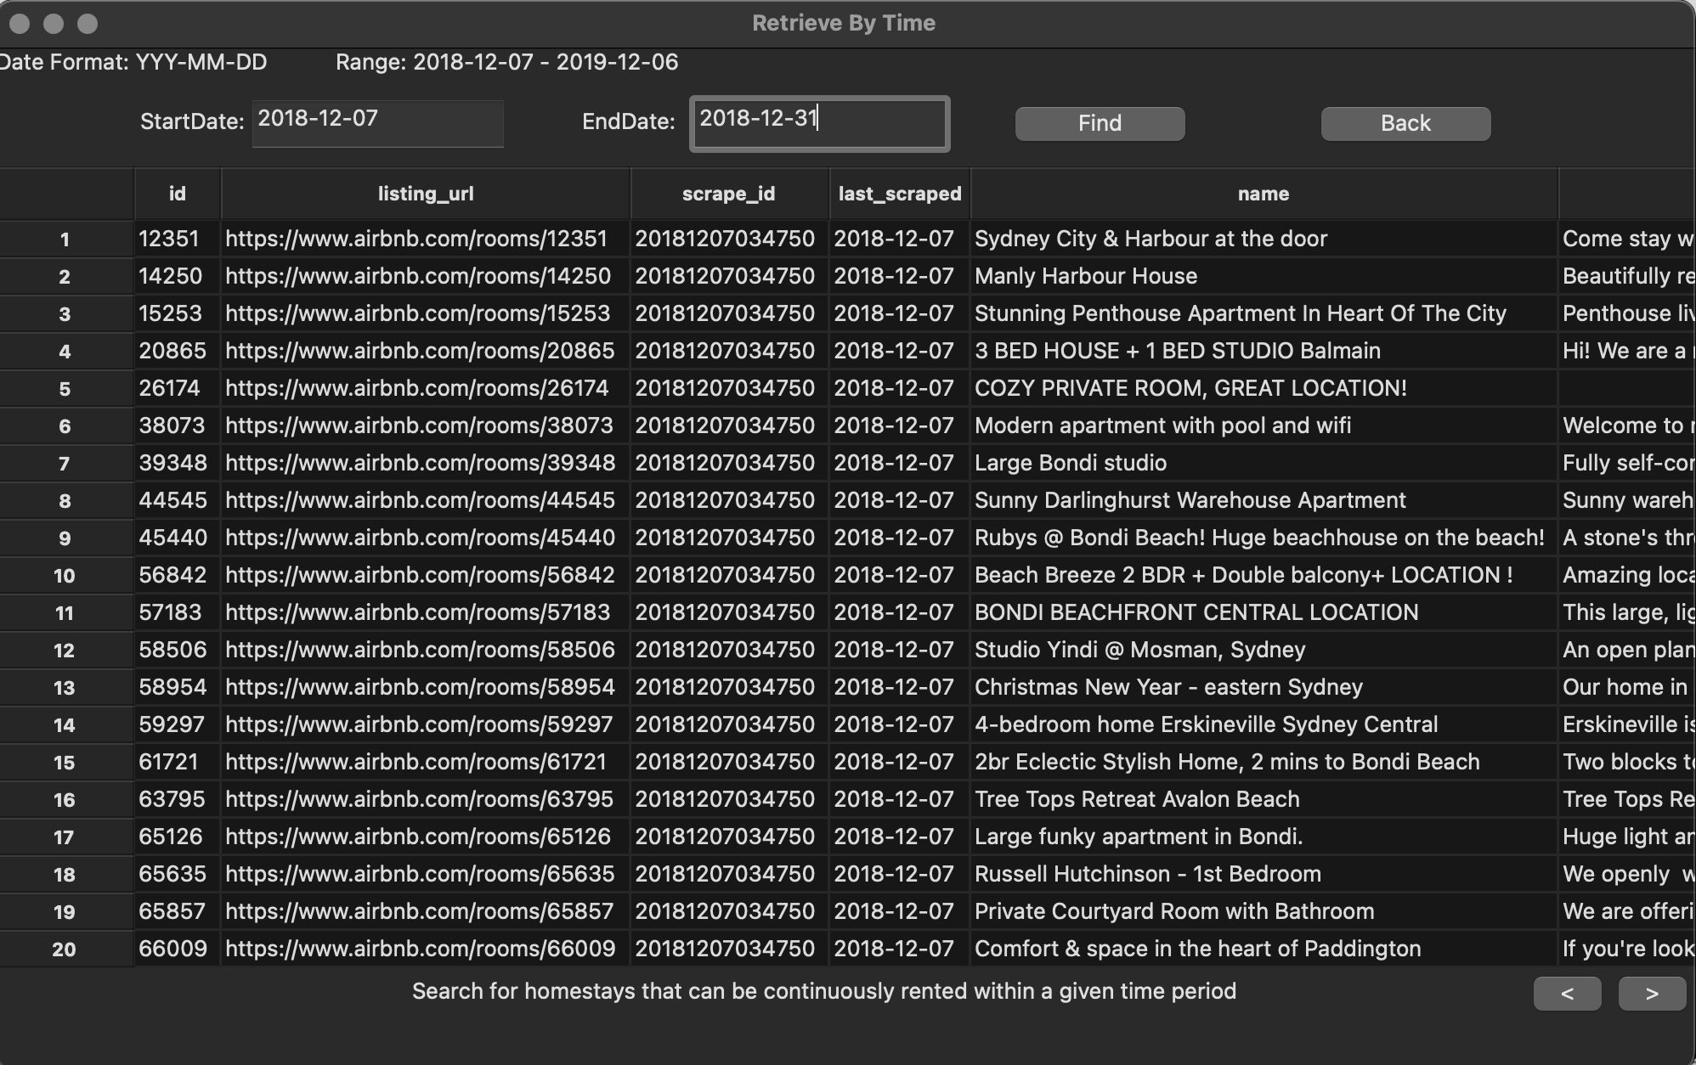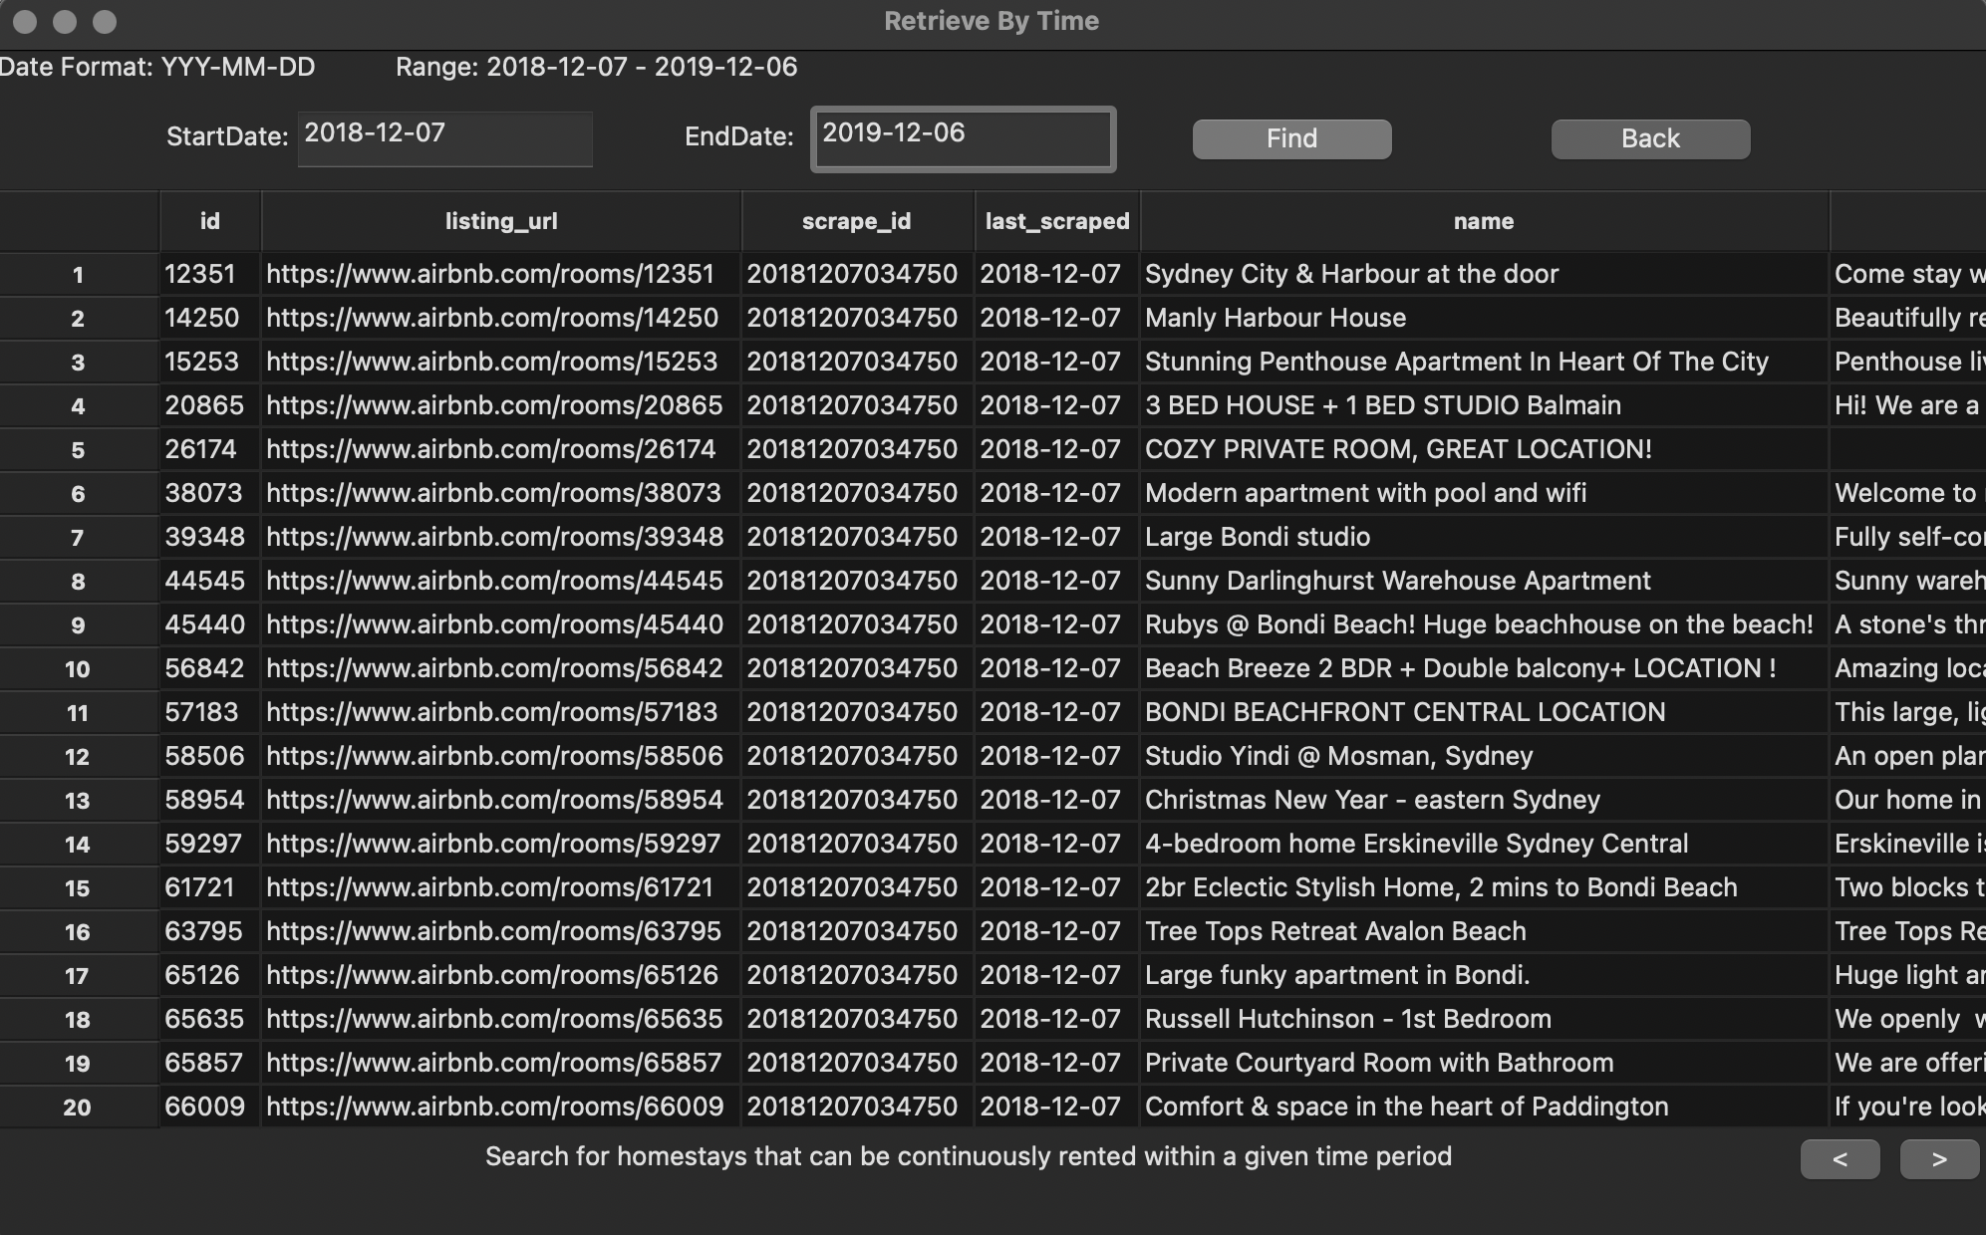

# **Distribution of price of all listing properties**

* Users enter the StartDate and EndDate and click “Find” button. The result shows average property price of street (bar chart)
* Datetime must be year/mm/dd, otherwise error message will be shown
* Drop-down menu indicates different street
* Not Found result only exist when user enter invalid date as well as not filling up the blank
* User can click “Back” button to return to the main window

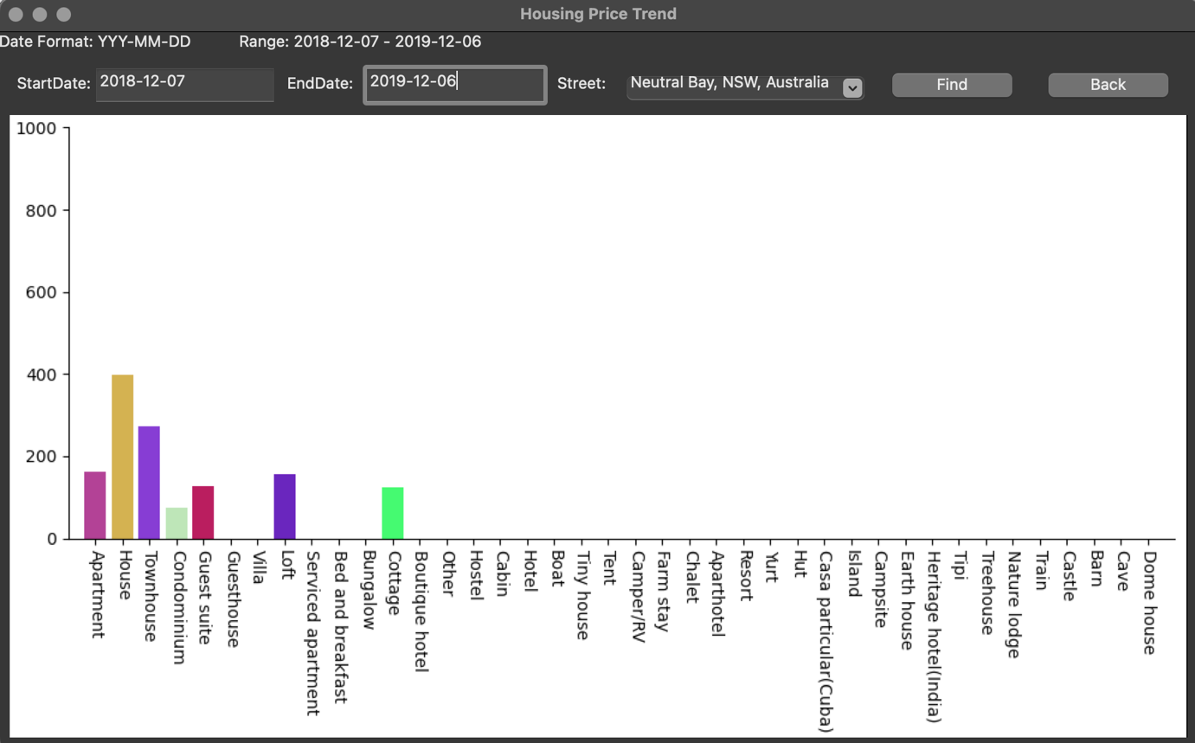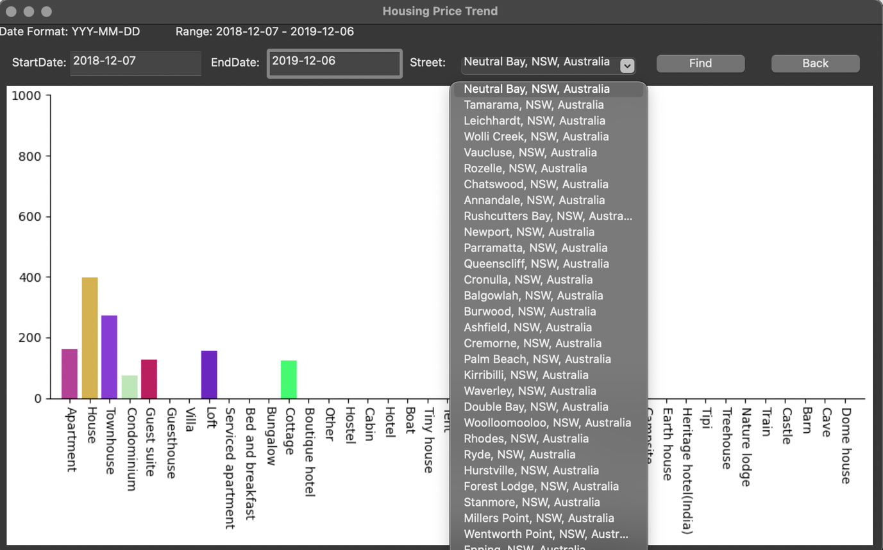

# **Retrieve all records that search by keywords**

* Users enter the StartDate and EndDate, and enter specific keywords
* Click “Find” to search the result of user input
* Datetime must be year/mm/dd, otherwise it will alert error message
* User can click “Back” button to return to the main window

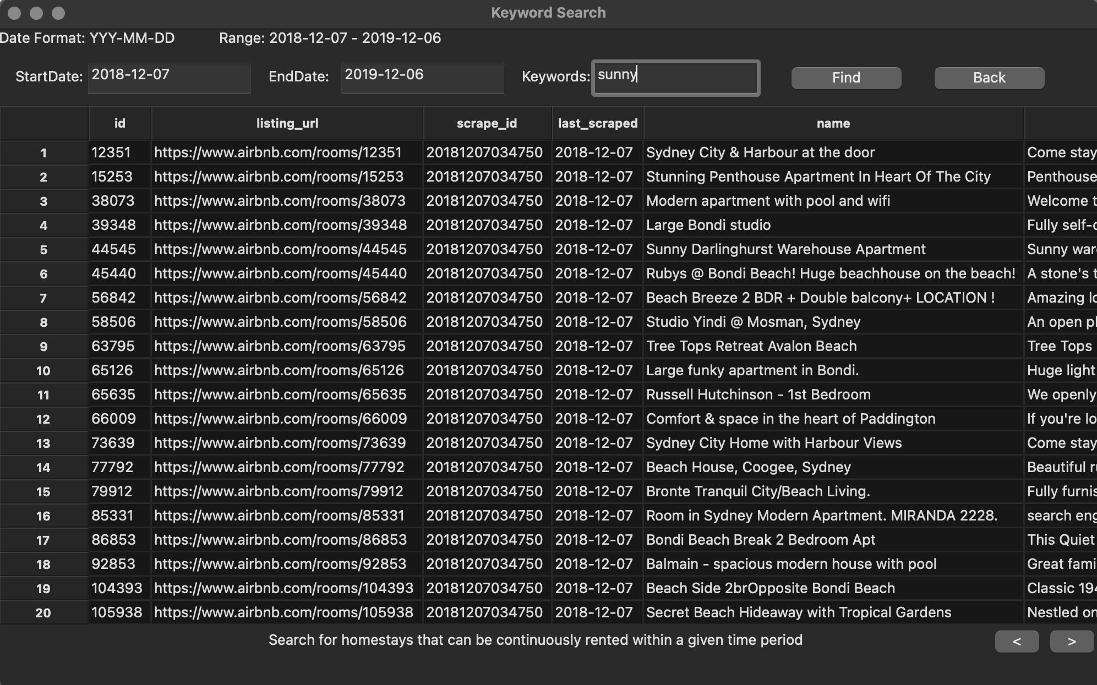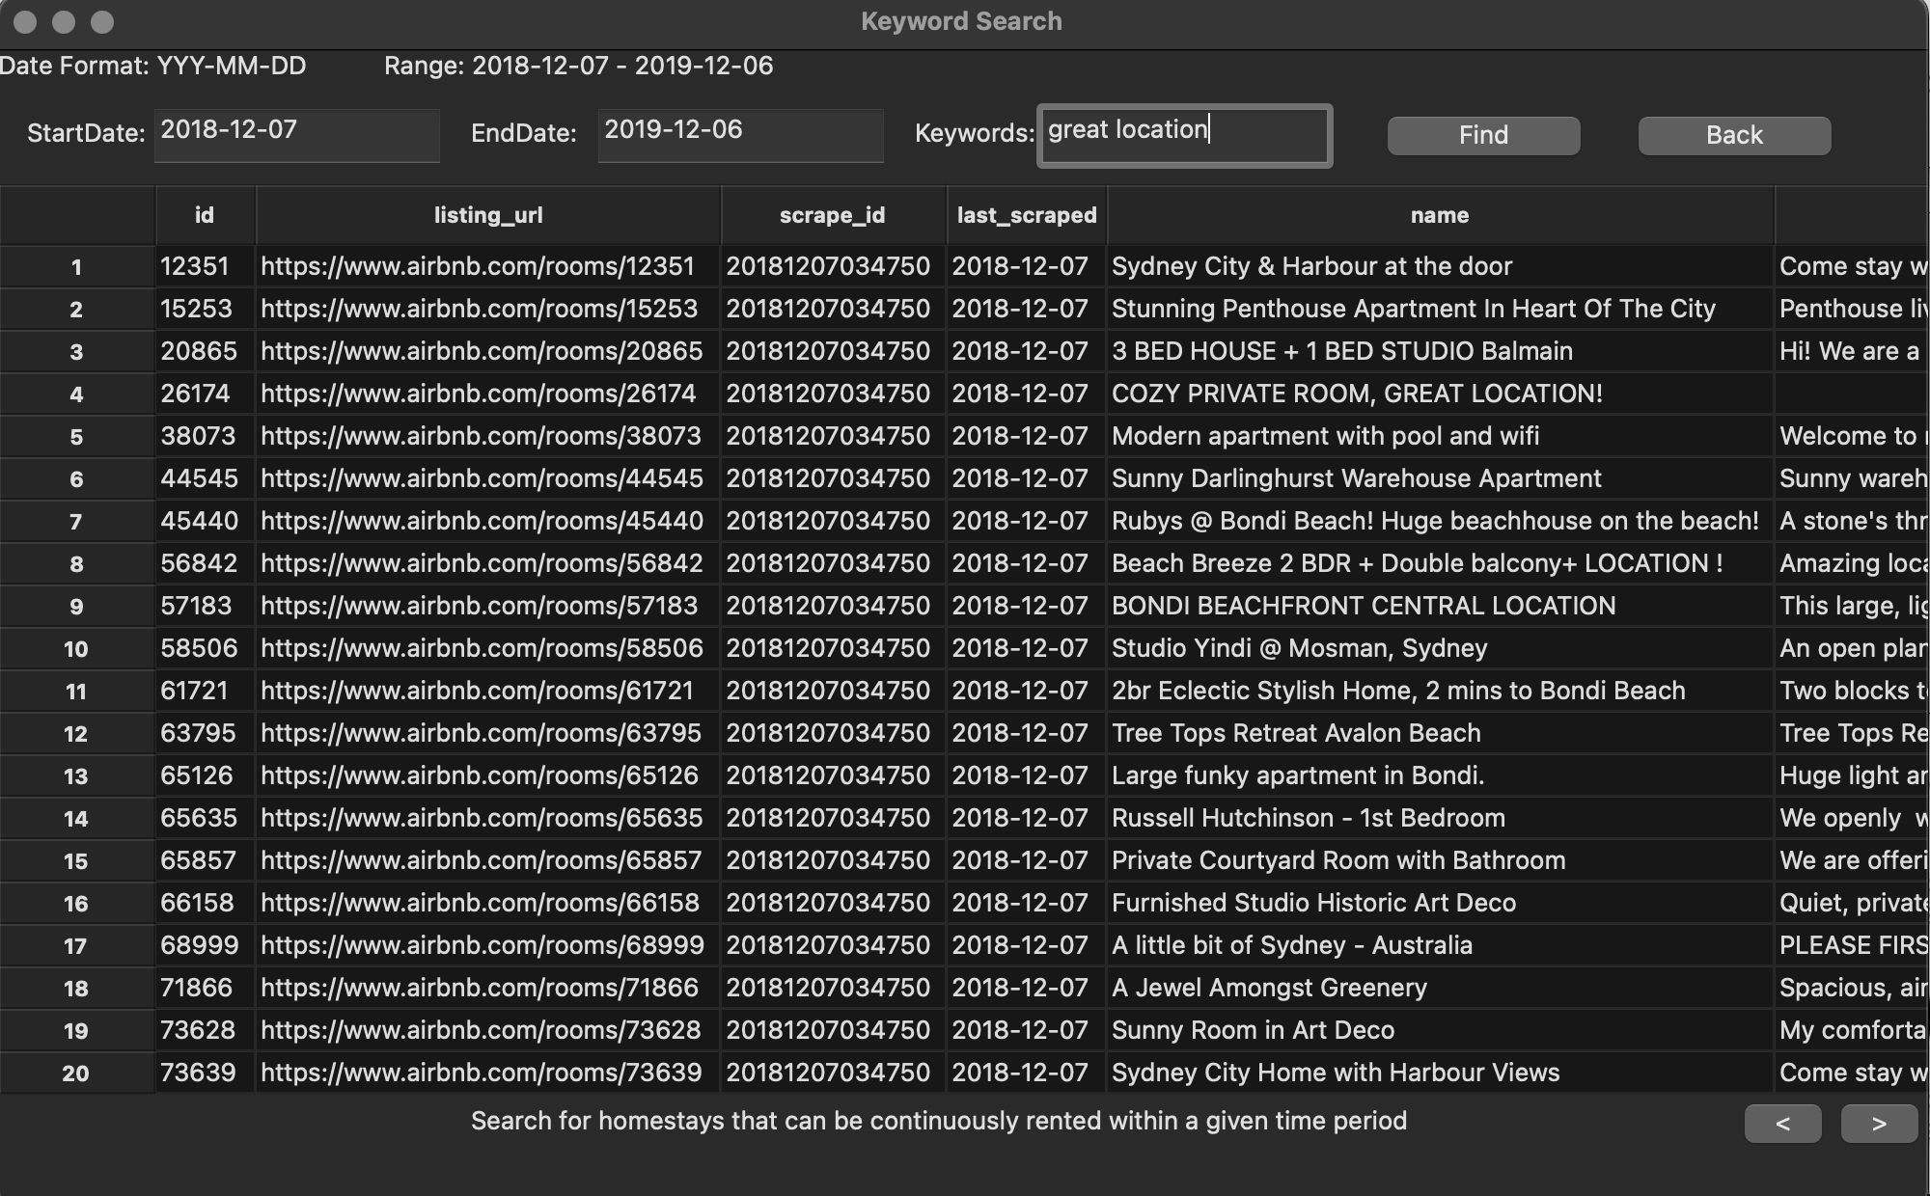

# **Analyse cleanliness based on the number of reviewers**

* Dropdown menu indicates different keywords that define cleanliness of each type of property.
* Corresponding bar chart will be displayed after selected desired keyword. Data is retrieved from customer reviews/ feedbacks on Sydney Airbnb. Customer’s comment contains selected keyword will be counted.
* User can click “Back” button to return to the main window

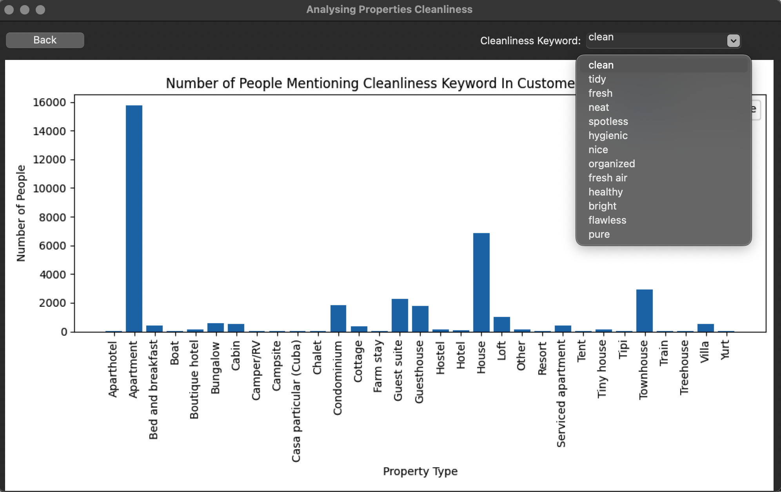

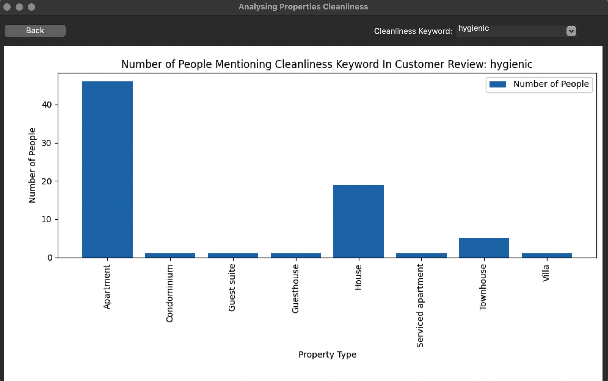

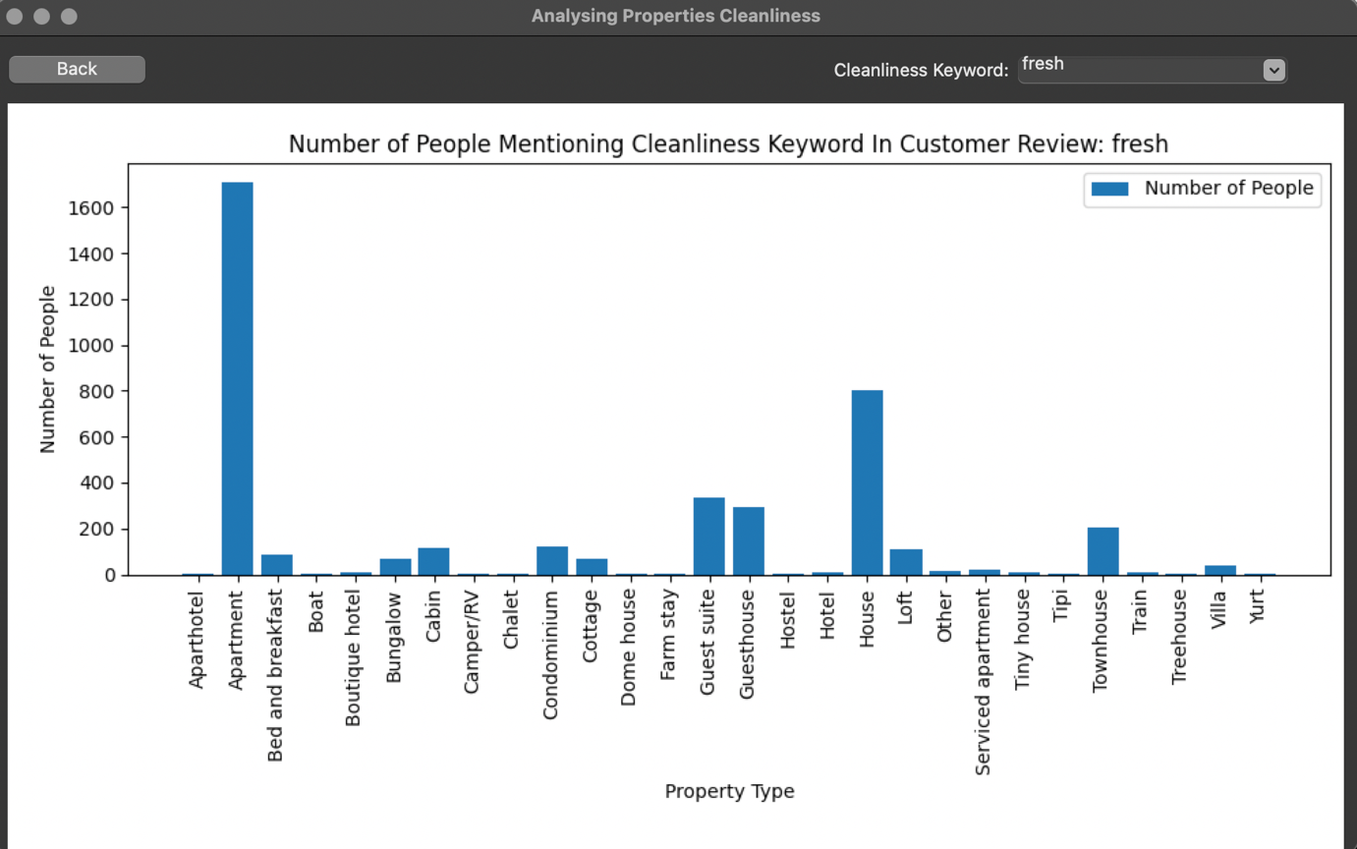

# **Display rating of properties**

* Viewing review scores for each property with review accuracy and the number of customer reviews.
* User can click “Back” button to return to the main window

